|  |
| --- |
| THE UNITED CHURCH OF ZAMBIA |
| **MENTORSHIP PROGRAM REPORT** |
| Technical support visit to Youths, Trainers and Mentors in Luapula Province for the period  18th December 2015 to 8th January 2016  Prepared by:  **Deaconess M.K. Sichali and Dr. A. Simwanza** |
|  |
| **January 2016** |

Table of Contents

LIST OF ACRONYMS 2

1. INTRODUCTION 3

Table 1: Establishment of In and Out School Youth Groups and, Training of Peer Educators by Sub-Recipients 3

2. PROCESS 4

3. OVERAL POSITIVE OBSERVATIONS 4

3.1. Trainees or pupils 4

3.2. Teacher or mentors 5

3.3. Trainers or facilitators 5

3.4. Church leaders, parents and other community leaders 5

4. CHALLENGES 5

4.1. Training schedules 5

4.2. Trainers or facilitators 6

4.3. Mentors 6

4.4. Parents, counsellors and elders 6

4.5. Trainees or pupils 6

5. SUPPORT PROVIDED 6

5.1. Kalasa Basic School 6

5.2. Mbereshi Mission Basic School 8

5.3. Mbereshi Community Peer Group 9

5.4.Kazembe (Mwansabombwe) Community Peer Group 10

5.5. Mable Shaw Secondary School 12

5.6. Salanga Basic School 12

5.7. Chinyanta Secondary School 12

5.8. Kazembe Secondary School 13

6. RECOMMENDATIONS 13

6.1. For the Schools and communities 13

6.2. For the UCZ 13

6.3. For CHAZ and other cooperating partners 13

7. CONCLUSION 13

ANNEX 1: CHURHES HEALTH ASSOCIAON OF ZAMBIA CHAZ-GF NFM HIV-TB PROGRAMME 14

# LIST OF ACRONYMS

**AIDS** Acquired Immunodeficiency Syndrome

**PMO** Provincial Medical Office

**DMO** District Medical Office

**HIV** Human Immunosuppression Virus/

**TB** Tuberculosis

**ART** Anti-Retroviral Therapy

**UCZ** United Church of Zambia

**CHAZ** Churches Health Association of Zambia

**PMTCT** Prevention of Mother to Child Transmission of HIV

**ARV** Anti-Retroviral

**VCT**  Voluntary Counseling and Testing

**VMMC** Voluntary Medical Male Circumcision

**OVC** Orphans and Vulnerable Children

**SBC** Sexual Behavior Change

# 1. INTRODUCTION

The United Church of Zambia is lead sub recipient of Global Fund from CHAZ for Sexual behavior change training in Luapula Province. The training of in school and out of school youths was conducted from 30th September 2015 to 31st December 2015 as shown in the Table 1 below:

## Table 1: Establishment of In and Out School Youth Groups and, Training of Peer Educators by Sub-Recipients

|  |  |  |  |  |  |  |
| --- | --- | --- | --- | --- | --- | --- |
| **Name Of Sub-Recipient** | **Province** | **District** | **Names of In School clubs** | **Names of out of School Clubs** | **Actual Training Dates** | |
| **In sch. PEs** | **Out of sch. PEs** |
| United Church Of Zambia. | Luapula | Mwansabombwe | Marble Shaw Sec | Mbereshi | 30th Sep – 9th October 2015. | 4th - 09th September 2015 |
| Kazembe Sec | Kazembe in place of Salanga | 15th - 24th October 2015. | 27th Oct - 5th Nov 2015. |
| Chinyanta Sec | Lubansa | 27th Nov- 06th Dec 2015. | 21st -31st Dec  2015. |
| Salanga Basic | Chipunka | 27th Nov- 06th Dec 2015. | 21st -31st Dec  2015. |
| Kalasa Basic in place of Chilindi Basic |  | 11th – 20th Dec 2015. |  |
| Mbereshi Basic |  | 11th - 20th Dec 2015. |  |

The overall target was to train 120 in school youths and 80 out of school youths and be able to reach out to 1070 adolescents in Luapula Province by December 2015. The United Church of Zambia (UCZ) conducted a series of trainings, in order to invigorate SBC messages on sexual reproductive health, HIV/AIDS, VMMC, Prevention, life skills to adolescents that are in school and out of school in Mwansabombwe District of Luapula Province.

Following the completion of training, UCZ Synod intended to conduct a mentorship support visit to the said schools and communities from 18th December 2015 to 8th January 2016. The groups visited were Mbereshi Community, Kazembe (Mwansabombwe) community, Mabel Shaw Secondary school, Kazembe Secondary school, Chinyanta secondary School, Mbereshi Basic, Kalasa Basic, and Salanga Secondary school. The objectives of the mentorship and technical support were to:

* Review the challenges being faced by trainers, mentors and trainees
* Assess the process of training for those who were undertaking the training
* Assess the knowledge, attitudes and practices (KAP) of those who had already been trained

Therefore, this report will discuss a few salient issues in each group, overall observations challenges and recommendations made.

# 2. PROCESS

In the first place the trainers, and mentors were interviewed to find out how the training was being done. They shared their perspective and issues requiring attention for them to provide the necessary support to the trainees.

In order to assess the process of training, time was allocated to review the training materials, listen to the presentations of the lesson plans by the trainees, and also observe the comments provided by both the peers and the trainers.

For those who had already been trained meetings were arranged and questions were asked for them to provide answers as a way of verifying that learning had taken place. Furthermore, the groups were given an opportunity to provide documentation of what they had done after the training.

The key output was the assessment of the performance and implementation of training program

The Health Secretary worked with the Community Development and Justice Secretary of UCZ. The assignment was designed to provide face to face interaction and consolidate the initial outputs of the trainings for improved sexual behavior change for the youths.The support relied heavily on the capacity of each training group to prepare lesson plans, peer reports and maintain their initial momentum or training enthusiasm. .

# 3. OVERAL POSITIVE OBSERVATIONS

This is the highlights of the positive observations noticed by learners/pupils, mentor/teachers, trainers/facilitators and guardians, parents, church elders and councilors.

## 3.1. Trainees or pupils

The targets reached were that 80 youths were trained and they had reached 937 youths (500 in Kazembe, and 437 in Mbereshi). The discussion with all the groups (learners/pupils) was very fruitful and they were able to bring out the key lessons from the training and its benefits. Some of the things mentioned are as follows: Harmful Traditions e.g. Sexual cleansing, Polygamy, Concurrent sexual partners. Others are Puberty and body Changes, Family Planning, Health relationships and unhealthy relationship, GBV, Dialogue, and the difference between Gender and sex. They also alluded to the benefits of life skills.

The groups confessed that the training had more advantages than disadvantages. They agreed that they had learnt a lot of things and that this was an eye opener to them, families and friends. They learnt about drug and alcohol abuse and its consequences, how to protect themselves from early pregnancy and STIs and HIV/AIDS. They confessed that they now know how to use condoms correctly.

It was discovered that during their presentations pupils were generally audible. They exhibited understanding of the modules. They were smart and confident and frank in the way they expressed themselves. However it was noted that for those who were still shy and needed encouragement, a mechanism was available to support them during the training.

## 3.2. Teacher or mentors

The teachers/mentors appreciated the program as it served as a catalyst of their existing roles as guidance teachers. Furthermore, the program increased the effectiveness of the school programs such as Anti AIDS clubs, career guidance,

Teachers or mentors too were enlightened. The teachers reported that the training was more practical and easy to teach. Before they taught out dated materials and were too theoretical. But with this practical approach they were able to address negative traditional practices. Information affected the learners positively academically. Teacher were optimistic that the information would help minimize early pregnancies.

## 3.3. Trainers or facilitators

The trainers of facilitators had an opportunity to voice out their needs, concerns, challenges and frustrations, they were encountering in performing their task.

## 3.4. Church leaders, parents and other community leaders

A discussion on how their church doctrines were affected by the training revealed that, the group members understood that doctrine was meant for helping them to stop destruction and the sexual reproductive training had the same objective.

The church leaders from different churches, parents and councilors confirmed that the peer educators were doing a good job.

# 4. CHALLENGES

Some key issues and challenges were observed during this process as outlined below:

## 4.1. Training schedules

The initial training dates were changed from the period 14th September 2015 to 30th November 2015 to the period 30th September 2015 to 31st December 2015

The training at Chilindi Basic was changed to Kalasa Basic because the school administration of Chilindi clearly said that they had only pupils in Grade 6 thus making it very difficult for their understanding of the whole concept of the planned training. Thus the change to go to Kalasa Basic that had grade 8 and grade 6.

In the out of school there was also a change in the communities from Salanga to Kazembe since Kazembe had a larger population as compared to Salanga which was closer to Chipunka and would be covered by the Peer educators from Chipunka as well as Salanga Basic Peer educators.

## 4.2. Trainers or facilitators

Though a letter had been written by the UCZ General Secretary to inform the DMO about the role Mr. Kasawa Chowa was supposed to play in training of the pupils, there was a need to write another one to the PMO who would in turn instruct the DMO to release Mr. Kasawa Chowa for subsequent trainings.

## 4.3. Mentors

The mentors and peers felt they needed to be paid for the work they were doing. Despite acquiring a lot of skills they felt education support and parental involvement was very important.

## 4.4. Parents, counsellors and elders

There was a serious out-cry that the parents were left out in the program. They continuously insisted parents should be included in the program even though the background to the project was explained to them.

## 4.5. Trainees or pupils

All the groups testified that it was a challenge to communicate to the church leadership, community and parents because of the difference in age group as well as the language used. They all felt that there was need for parents to be actively involved.

# 5. SUPPORT PROVIDED

The support from the Synod Office included local face to face encouragement, resource mobilization and linkages with external partners.

Below is the summary of the findings and support provided to each of the trainers, trainees and mentors.

## 5.1. Kalasa Basic School

Kalasa School has 1,170 pupils with 8 teachers. A 10 day training was in progress from 11th December 2015 to 19th December 2015. The structure of the training was that, a total of 20 pupils were trained as peer educators and there were 2 teachers who served as mentors. The teachers were Mr. Kambobe Isdore and Ms. Michel Namugala who both served as guidance teachers at the school.. The trainers were Mr. Kasawa Chowa, a male nurse from Mansa District. Mrs Nawale from UCZ synod office coordinated the training.

Though a letter had been written by the UCZ General Secretary to inform the DMO about the role Mr Kasawa Chowa was supposed to play in training of the pupils, there was a need to write another one to the PMO who would in turn instruct the DMO to release Mr. Kasawa Chowa for subsequent trainings.

As for the 2 teachers who served as mentors, they indicated that the training program was well suited with their roles in school. The existing scenario was that only 2 teachers could provide information on sexual reproductive health and life skills. With the training of 20 pupils, the teachers felt that an extra 20 peer educators would augment their work. The school has had guidance and counseling as a cross cutting issue which already exists on the timetable. The school time table has

* Life skills as part of all subjects
* School clubs such as Anti AIDS clubs
* Careers sessions
* Holding of Workshops for parents, guardians, and church leaders,

The following advantages were articulated under each of the issues highlighted above.

For life skills, the theory part which was only reflected on paper was now made to be practical by the training of 20 pupils. The training also provided for latest resource material as the existing ones at the school were outdated. The training opened up for mentors (teachers) to know their learners much better. As an example, a lot of traditional cultural issues were revealed by the pupils during the training.

As for the school clubs, the membership was expected to increase to be spearheaded by the 20 peer educators instead of only relying on the teachers. The clubs would also have materials

In terms of career support, the academic performance of the pupils was anticipated to improve due to the training resource materials which was in line the existing subjects. It will also curb early marriages.

The financial support of K3, 000 would help in holding a one day duration workshops for parents, church leaders instead of the existing 3 hour workshops. The financial support would enable the school to provide refreshments and resource materials for the participants

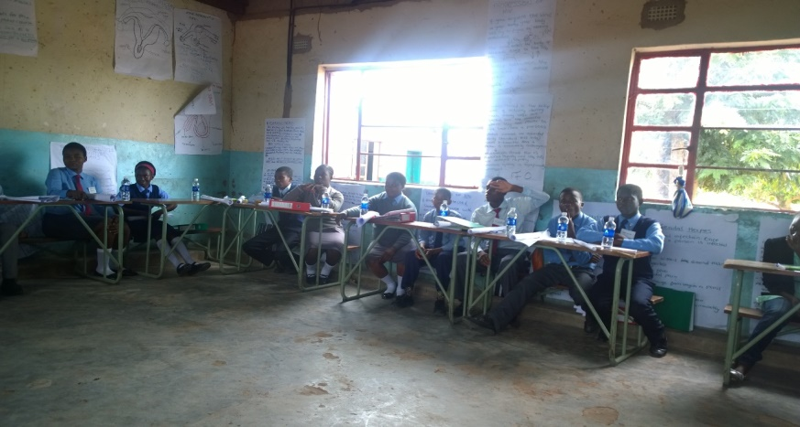

The interaction with the pupils included reviewing some of the lesson plans which the pupils were preparing. Furthermore, one 16 year, grade 6 female pupil by the name of Beatrice Musonda was interviewed. She revealed that she had learnt how to negotiate with people, how to prevent HIV infection, the goodness of Family planning, and effects of unsafe abortion, the female and male reproductive system, traditional harmful practices, difference between gender and sex. At individual level, she stated she would live to prevent being infected by HIV and getting unwanted pregnancy. She was also able to develop a program on how to teach others as a peer educator. She looked forward to arranging a group of fellow Grade 6 pupils and share with them what she had acquired. The teaching plan would include the topic, introduction, main body, application and summary.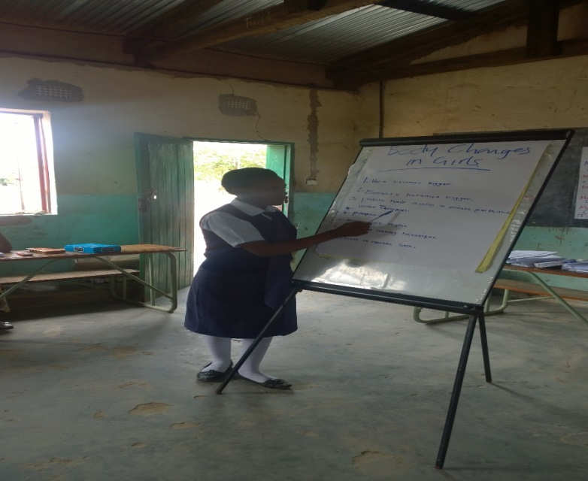

## 5.2. Mbereshi Mission Basic School

Mbereshi Mission Basic School has 5076 pupils with 17 teachers. A 10 day training was in progress from 11th December 2015 to 19th December 2015. The pupils made presentations, the other pupils corrected one another or provided a critique and the trainer made observation as a conclusion. At the time of the visit, the team observed presentation from 3 pupils as shown below:

* Chainda Naomi presented on female and male reproductive system. The comments from her peers were that the dressing was well, the written material were readable, and she was able to answer questions and had good pronunciation. However, she was advised to work on the issue of back staging and appearance as a peer educator is supposed to be an example.
* Penelope Chilombo presented on body changes for boys and girls aged 10-14 years. She indicated that hormonal changes, physical changes, emotional changes. The comments from her peers were that she was too stationary, she was back staging, had poor pronunciation, poor handwriting and was not audible. She was advised that she needed to have understood her own writing before making a presentation.
* Penelope Kabaso presented on gender and sex. She explained gender roles and biological sex. She was advised to be confident in talking about sex.

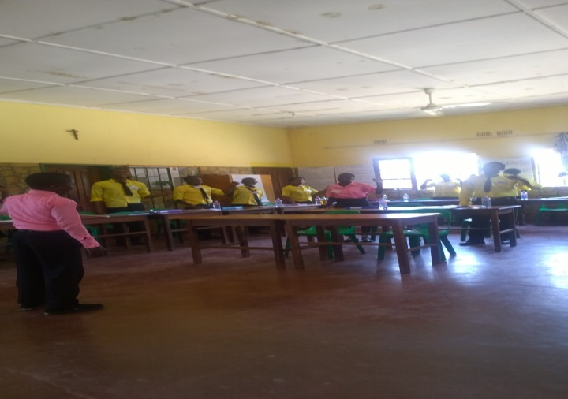The discussion with the trainer Mrs Mercy Mvula, a female nurse from Mbereshi Mission Hospital, indicated that, she had modify the lesson plan by simplifying it. The standard lesson plan has a table while the improvised one had no table but actual notes. She stated that, the pupils were not able to understand the original lesson plan. As evidence of training a register was available on the daily basis.

The mentors (teachers) at Mbereshi Mission School were Mrs Sondashi Salome and Mr Mutale Moses. They both indicated that the information was useful in society and that the topics were curriculum issues which are part and parcel of the introduction in integrated science and social and developmental studies. The new topics were traditional practices. They felt that the information would lead to behavioral change. They indicated that in the selection of pupils, they left out examination classes. This was so because, they would go to other schools or would not come back after exams.

## 5.3. Mbereshi Community Peer Group

Mbereshi Community Peer Group comprises members from UCZ, Catholic, SDA, and Apostolic Pentecostal Churches. The group was trained from 4th September 2015 to 12th September 2015. 20 Youths were trained consisting of 4 per each church denomination. However at the time of the visit the group had reduced to 8 members. 8 members had been transferred out of Mbereshi community.

After the training each of the denomination made denominational action plans as follows:

* UCZ targeted to reach 40 youths and had reached 48
* Catholic targeted 40 and had reached 40
* Pentecost Holiness targeted 160 youths and had reached 186 youths
* SDA targeted 40 and had reached 173 youths

They had an executive in place and had action plans according to their churches.

During the visit 8 members were met and the following discussion ensued:

The group member identified the following advantages of the training. The members were able to maintain healthy family relationships, understood harmful traditional practices such stopping sexual cleansing. They also stated that polygamy would be reduced. Other things included knowing the behavior of puberty teens and freedom to allow the teen to express themselves during puberty experiences.. The group identified an unhealthy relationship as where there is misunderstanding and a health one as one where there is order. The group members knew the difference between gender and sex. The life skills of knowing oneself and others were also highlighted including making effective decisions. They knew the benefits and disadvantages and consequences of bad decision making. Alcohol and drug abuse was also discussed. They felt the training was helpful in preventing diseases and unwanted pregnancies.

A discussion on how their church doctrines were affected by the training revealed that, the group members understood that doctrine was meant for helping them to stop destruction and the sexual reproductive training had the same objective.

The group had a meeting and chose an executive. The youths were free to collect condoms from the hospital for distribution.

The challenges encountered were on briefing the church elders. The plan was to introduce the training to different age ranges separately. For 10-14 years topics on puberty were introduced while 19-24 ages had different topics. They gave an example of one teenage who experienced body changes and had no anxieties over the issue. People are free to ask. When asked as to whether the elders felt the topics were insults. They were therefore advised to tone down on the language.

SDA had challenges to convince the leadership at church. The challenge of 8 members who had been transferred was to be mitigated by requesting for mothers to be trained. A request had been made to the Synod;

It was recommended that they meet to share best practices. Further recommendation was that the group comes up with TOR. There was need to meet elders and other facilitators

The future plans of this group is to train with other peers the modules they never learned like peer education because their training was done for 6 day. They also plan to replace the 8 peers who are no longer in Mbereshi and come up with one action plan. They need professional skills

## 5.4. Kazembe (Mwansabombwe) Community Peer Group

Mwansabombwe Peer Group comprises members from UCZ, Catholic, Apostolic Pentecostal Churches and 8 from the community nominated by the councilors. The group from the community was 8 because, it had to cater for members from SDA who had been denied the opportunity to participate in the program. It was discovered that one SDA member was chosen by the community and was freely contributing to the program. 20 Youths were trained consisting of 4 per each church denomination and 8 from the community which included a member from SDA. At the time of the visit the group had all the members active except for one.

After the training the group formed one committee and chose an executive consisting of a President, Vice President, Ministers of Health, Finance and Religious affairs. They developed TOR of how to meet, handle finances etc. They have been conducting trainings as group zone by zone until they finish all the 10 zones in the community which is divided into 4 sections. They approach political ward councilor and community leaders who give them different zones to train. They train 30 youths weekly on Sundays covering 2 topics per training. The group had sensitized more than 500 community members. The arrangement is such that they first see the village headman, and then sensitize the youth. They hire a Public Address (PA) system from Pentecost Holiness Church and at 1300 hours gather the youth into sections namely 10-14 years and 16-24 years separately.

They approached their church and community leaderships differently. UCZ youths reported to the church secretary and the topics were announced in the congregation. Pentecostal Holiness leadership were sensitized by the trainers and that made it easier for the youths to get a go ahead from the church. The catholic youth spoke to parish Father and the community youths approached the ward councilor.

The positive changes or results highlighted from the training include

* People see the youth in public and that makes the behave themselves as role models
* They were respectful and built good relationships in the community.
* They were able to dialogue and their dress code had changed for better.
* They had made good friendships with people in the community

It was observed that this was a very vibrant peer group. Have learnt how to live with others. 99% were conversant with the modules and the group had a well tabulated action plan.

There was need to meet elders and other councilors. Their views were as shown below:

* Church leaders said age should to be reconsidered and allow un-married youths who are over 24 years.
* Include couples in the project as most of them are not aware of the STIs apart from Syphilis, even some of the church leaders needed the knowledge.
* The general comments were that the project was new but it was well received.
* The project to be introduced during Mutomboko.
* The church leaders from different churches confirmed that the peer educators were doing a good job.
* Knowledge was acquired as one could tell by noticed changes in the life of peer educators. i.e. dressing, conduct, speech and they were more assertive now than before
* Family planning module not well received by church leaders as they felt it will promote illicit sex.

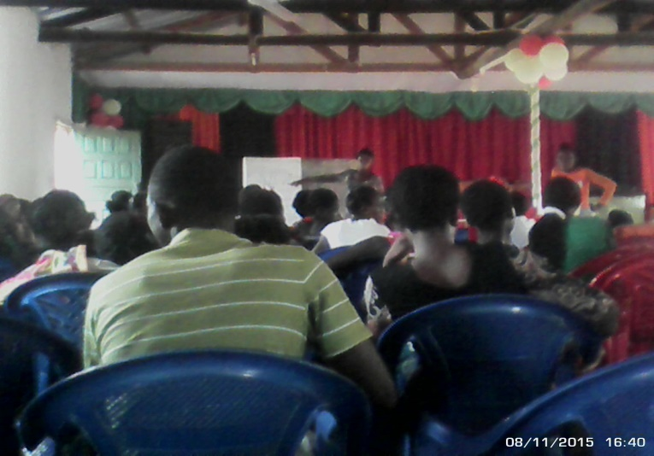Recommendations

* Continuation of project
* Need more peers trained because the place is vast and that the problem of illicit sex is big.
* Buy T. Shirts for identity.
* Need bicycles for easy transportation.
* Need mega phones for easy communication

## 5.5. Mable Shaw Secondary School

Management appreciated the project and that it had awakened the pupils. They also noted that the girls who participated have tremendously changed in behavior and their approach to life had improve such that you could tell by their dressing.

The project acted as a catalyst and Anti AIDS clubs have been revamped and they are at the top in terms of activities especially with the technical support given to them.

They had 9 pregnancies as at September 2015 so management thanked UCZ and CHAZ that the project came at the right time. They are hopeful that the project will minimize the cases of pregnancies and forced marriages.

## 5.6. Salanga Basic School

Both parents and teachers welcomed the project. Parents were very happy but felt they were left out in the project. They recommended that the T. shirts be bought for them to be identified as they work in the community. The Action plan was made.

Challenges:

* Negative attitude of parents towards education.
* Pupils luck parental guidance on beer drinking.
* Fish comp area so premarital sex is common
* Poor livelihoods
* Re-entry policy has caused many girls to have an I don’t care attitude thinking even if they fall pregnant they will be readmitted in School. Most of them who fall pregnant

Recommendation

* Education Support
* Nutrition Support

## 5.7. Chinyanta Secondary School

In 2015 Chinyanta recorded 11 pregnancies between the ages of 13-19.The school authorities welcomed the project because the project was supplementing Campaign for female education (CAMFED). They sponsor pupils to tertiary education. It was stated that premarital sex was high. The pupils were very excited over the project especially over the transport re-fund given to them as some of them paid for their school fees and bought food at home. For this the parents were very grateful.

Challenges identified were that it is important to consider primary schools because girls start having sex as early as 9 years.

They recommended that they needed the sensitization during Mutomboko during the last Saturday of July because there is a lot of illicit sex.

## 5.8. Kazembe Secondary School

It was noted that the project came at a time Grade 7 and 9 had written their exam. The program was welcomed because it came at a right time and pupils behaviors is slowly changing. They did not involve examination classes for fear that they might be distracted. They had formulated an Ant AIDS club and it was very active with technical support. The team thought the program was good timing because most pupils are not yet exposed to sex. They also said the trainer showed innovativeness. Teachers acknowledged that the project was new in the district. Thus they welcomed the move.

The mentors reported that they had no problems with administration except for few teachers who felt the language used was strong. The project was welcomed by both teachers and PTA. They wanted to be bought T. Shirts identity and bicycles. They had produced the action plan for 2016.

# 6. RECOMMENDATIONS

Outlined below are key recommendation of the overall process..

## 6.1. For the Schools and communities

* They needed the sensitization during Mutomboko during the last Saturday of July because there is a lot of illicit sex is done.
* Meet to share best practices
* Mitigate the dropout rate of some youths by training others

## 6.2. For the UCZ

* There was a need to write another letter to the PMO who would in turn instruct the DMO to release the trainers/ facilitators. Mr Kasawa Chowa and Mrs Mercy Mvula for subsequent trainings.
* Process and forward requests from youth groups

## 6.3. For CHAZ and other cooperating partners

* review and print more training modules for the youth groups
* improve on the facilitation of the training schedules as earlier planned to allow adequate mentorship visits
* support the project during Mutomboko ceremony

# 7. CONCLUSION

In conclusion these mentorship visits were acutely crucial for all players in the sexual reproductive program. The participants fully appreciated the interaction with them in terms of improving their current services and achievements as well as aiming and directing future efforts.

# ANNEX 1: CHURHES HEALTH ASSOCIAON OF ZAMBIA CHAZ-GF NFM HIV-TB PROGRAMME

**Establishment of In and Out School Youth Groups and, Training of Peer Educators by Sub-Recipients**

|  |  |  |  |  |  |  |
| --- | --- | --- | --- | --- | --- | --- |
| **Name Of Sub-Recipient** | **Province** | **District** | **Names of In School clubs** | **Names of out of School Clubs** | **Tentative Training Dates** | |
| **In sch. PEs** | **Out of sch. PEs** |
| United Church Of Zambia. | Luapula | Mwansabombwe | Marble Shaw Sec | Mbereshi | 14th – 25th September 2015. | 1st – 10th September 2015 |
| Kazembe Sec | Salanga | 12th -22nd October 2015. | 26th Oct - 4th Nov 2015. |
| Chinyanta Sec | Lubansa | 12th -22nd October 2015 | 26th Oct - 4th Nov 2015. |
| Salanga Primary | Chipunka | 12th – 22th October 2015. | 26th Oct - 4th Nov 2015. |
| Chilindi Primary |  | 9th – 20th Nov 2015. |  |
| Mbereshi Primary |  | 9th - 20th Nov 2015. |  |

Name of responsible officer: Hellen Nawale Gondwe Muma.

Designation: Programs Officer E-mail address: nawalemu@yahoo.com

Contact Phone Numbers: 0978793502, 0965516276