**THE UCZ UNIVERSITY COLLEGE WILL HOST**

**A**

**Gender and Development Conference**

**TOGETHER TOWARDS A JUST, EQUITABLE AND SUSTAINABLE SOCIETY**

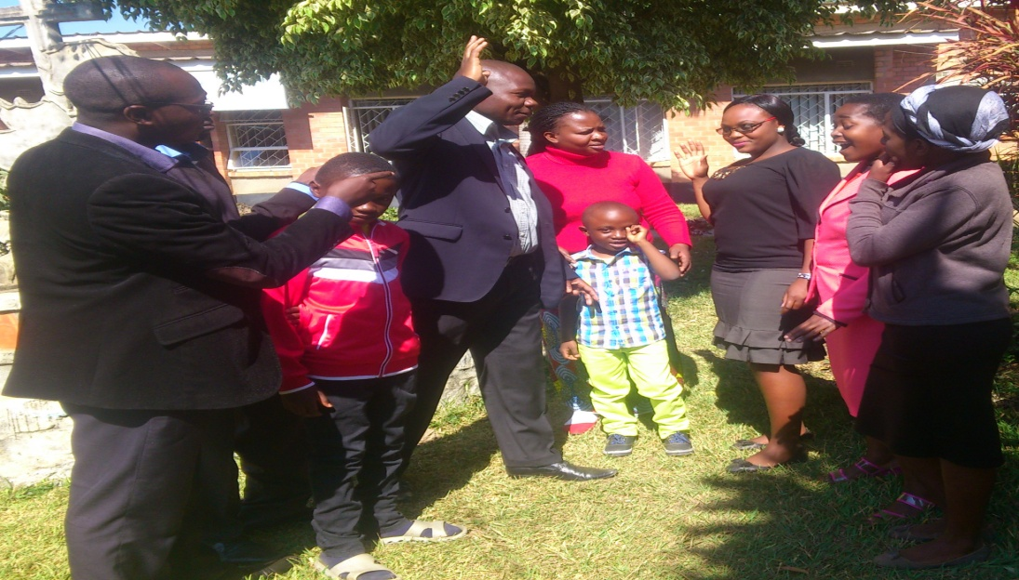

To be hosted by the UCZ University College

**Dates**: 14-15th August 2015

**Venue**: Charles Fisher Hall, Mindolo Ecumenical Foundation, Kitwe, Zambia

**Registration Fee**: K200 (covers conference fees and meals)

For further details: **Contact** the Conference secretary Rev Teddy Chalwe Sakupapa on email: [tecsak@yahoo.com](mailto:tecsak@yahoo.com) or phone 0977 591 016.

**Friday 14 August**

|  |  |  |
| --- | --- | --- |
| 08:00-08:50 | Registration |  |
|  | Chairperson: Rev Teddy Chalwe Sakupapa (UCZ University College) |  |
| 09:00-09:10 | Rev. Kapembwa Kondolo (Rector United Church of Zambia University College) | Welcome |
| 09:10-10:20 | Rev Dr. Peggy Mulambya (General Secretary United Church of Zambia) | Opening Remarks |
| 09:20-10:00 | Hon. Prof. Nkandu Luo (Minister of Gender and Child Development, Government of the Republic of Zambia) | Official Opening Address |
| 10:10-11:10 | Prof Owen Sichone (Copperbelt University) | **Lobola, Chisungu and Early Marriage: Understanding the Economic Significance of Ritual and Tradition in Gender Relations** |
| 11:10-11:30 | Tea Break |  |
|  | Chairperson: Dr. John Bwalya (Copperbelt University) |  |
| 11:30-13:00 | Panel Discussion  Fr. Leonard Chiti (Jesuit Centre for Theological Reflection), Ms Lumba Siyanga (Women for Change), Susanne Matale (Council of Churches in Zambia), Ms Joyce Kasosa (Copperbelt Police Commissioner), Mr & Mrs Nkhuwa (Matty Investments/Icon Hotel) | **Gender and Development: Voices in “Action”** |
| 13:00-14:00 | Lunch |  |
|  | Chairperson: Rev. Dr. Laishi Bwalya (MEF) |  |
| 14:00-15:00 | Dr. Adriaan Van Klinken (University of Leeds U.K) | **Masculinities and the Maleness of God: Theological Perspectives for Gender Transformation and Development** |
| 15:00-15:20 | Tea Break |  |
|  | Chairperson: |  |
| 15:20-16:05 | Ms Nelly Mwale (University of Zambia) | African Traditional Religion Harvest Festivals in the Context of Climate Change in Eastern Zambia: Teachings, Practices, Achievements and Challenges |
| 16:05-16:50 | Dr Lillian Siwila (University of Kwazulu Natal) | Whose Space whose Agenda: Gender Mainstreaming of the Interface between Church, Health and Development |
| 19:00 Hrs | Conference Dinner |  |

**Saturday 15 August**

|  |  |  |
| --- | --- | --- |
| 08:30 Arrivals | Chairperson: Mrs Jurita Mutale (Trauma Healing Centre) |  |
| 09:00-10:00 | Dr John Klaasen (University of the Western Cape) | The Role of Personhood in Development |
| 10:00-10:45 | Mrs Edith Z. Nawakwi (President, FDD) | Women Shaping Politics: Gender and Development |
| 10:45-11:05 | Tea |  |
|  | Chairperson: |  |
| 11:05-11:50 | Dr Thera Rasing (University of Africa) | Revitalising Women’s Roots and Knowledge for Development |
| 11:50-12:30 | Rev Teddy Chalwe Sakupapa (UCZ University College) | Putting Names to Faces: A Gender Perspective on the Interface Between Mission and Development |
| 12:15-13:00 | Dr D.T Banda (Justo Mwale Theological University) | Gender Constructs: Implications for Development in Church and Society |
| 13:00-14:00 | Lunch |  |
|  | Chairperson: Rev. Dr. Sidney Cooper (UCZ University College) |  |
| 14:00-14:45 | Mr Simson Mwale (Zambia Catholic University) | Violence Against Deceased Families in Zambia |
| 14:45-15:30 | Mr Kasenge (UCZ University College) | Impact of Fear of Femininity Among Men on Development: A Critical Analysis |
| 15:30-15:50 | Tea |  |
|  | Chairperson: Dr Adriaan Van Klinken (University of Leeds, UK) |  |
| 15:50-16:35 | Dr Fulata Moyo (World Council of Churches) | **Moving Together to Reach Far: Gender Justice, Peace and Sustainable Development** |

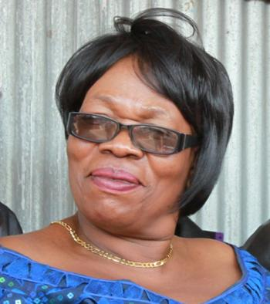**Prof Nkandu Luo** holds a masters degree in immunology from Brunel University and a PhD from the London School of Hygiene and Tropical Medicine. She is an experienced researcher who has also taught at the University of Zambia. Her political engagements have seen her serve in various senior government portfolios. She is presently the minister for gender and child development in the government of the Republic of Zambia.

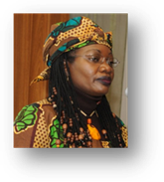**Fulata Moyo** is currently WCC’s Programme Executive for Women in Church and Society with the mandate to coordinate women’s global work through 349 WCC’s member churches. She holds a PhD in Religion and Theology focussing on Gender and Sexual Ethics. She is a member of OURs (Observatory on Universal Rights), The Carter Center Human Rights Defenders Forum Steering Group and other related initiatives. As Harvard Divinity School Research Fellow, February 1-May 31, 2015, she will be developing a Religious Ethic of Care that responds to trafficked and sexually violated women and girls. Her publications in journals and book chapters have mainly addressed the religio-cultural influence on gender construction and women’s sexuality. She co-edited, Women Writing Africa: Eastern African Region. New York: Feminist Press. 2007. Dr. Moyo is the outgoing General Coordinator of the Circle of Concerned African Women Theologians which, since its inception in 1989, has the mandate to undertake research, writing and publishing on African issues in Theology, religion, culture and health from women’s perspectives



**Adriaan van Klinken** holds a PhD in Religious Studies from Utrecht University (the Netherlands), was a Research Fellow at SOAS, University of London and is currently Lecturer in African Christianity at the University of Leeds (UK). His research focuses on issues of gender and sexuality in contemporary African Christian contexts and he conducted substantial research in Zambia on masculinity and on homosexuality. Among other publications, his book *Transforming Masculinities in African Christianity: Gender Controversies in Times of AIDS* was published with Ashgate in 2013. He is currently editing two books with Ezra Chitando: *Public Religion and the Politics of Homosexuality in Africa* and *Christianity and Controversies over Homosexuality in Africa*, to be published with Ashgate in 2016.

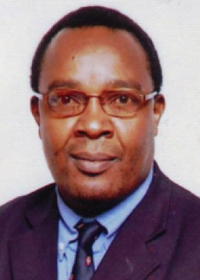

**Prof Owen Sichone** holds postgraduate qualifications from Sussex University and Cambridge in England. He is the currently Director of the Dag Hammarskjöld Institute for Peace and Conflict Studies at the Copperbelt University. He has previously taught at several southern African universities, including Wits University and the University of Cape Town in South Africa. He was also Nelson Mandela Professor in African Studies at Jawaharlal Nehru University in India. He is a political sociologist whose work includes studies on xenophobia and ethnic identities in South Africa, as well as of the state and democracy in Africa.

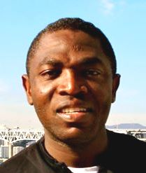**Rev Teddy Chalwe Sakupapa** is a lecturer in dogmatics and ethics at the UCZ University College in Kitwe, Zambia and a part-time lecturer in the department of Religion and Theology at the University of the Western Cape (UWC), South Africa. He holds a Masters degree in Dogmatics from the Protestant Theological University, Netherlands and a Bachelor of Arts degree in Religion and Theology from UWC. He is currently a PhD candidate in Ecumenics and Social Ethics at UWC. His research interests are in African Philosophy, pneumatology, ecumenical theology, and Christian social ethics.

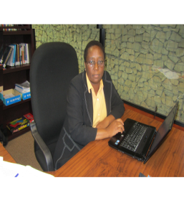

**Dr. Lillian Siwila** **Dr Lilian Cheelo Siwila** is a lecturer in the School of Religion, Philosophy and Classics. She is currently the Programme leader for Systematic Theology previously Programme leaders for pilot programme in Gender Religion and Health funded by the Church of Sweden. She has also worked with a number of ecumenical bodies such as WCC in the field of Gender, Theology and Culture holding various offices. She is a member of the Circle of Concerned African Women Theologians, CHART, Ujamaa, TTSA, and AARS among others. Her research interests include Gender, ecology and Culture. Sexual and reproductive health and its interface with Theology. Social and economic transformation in Contemporary Theologies.

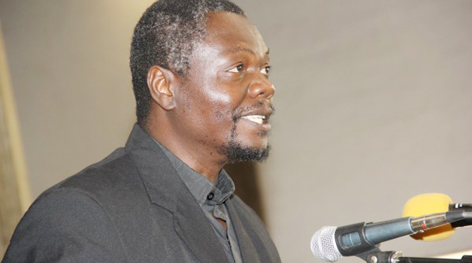**Fr. Leonard Chiti** holds a master’s degree in development studies from the University of London (SOAS) and a bachelor’s degree in philosophy and theology from Arrupe College, Zimbabwe. He is the director of the Jesuit Center for Theological Reflection and the Coordinator of the Global Ignatian Advocacy Network. He is also the Coordinator of Civil Society Constitution Coalition, Lusaka, Zambia. His research interests include issues in ecology, global socio-economic and political projects and formation programs for the Society of Jesus.

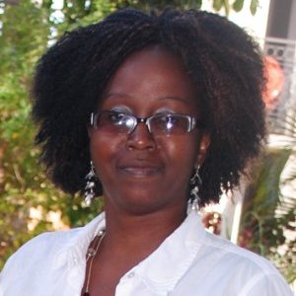

**Ms Lumba Siyanga** is the Executive Director of Women for Change, Zambia. She holds a Master of Arts in Development Studies with specialisation in Poverty Studies and Policy Analysis. Her interests lie in working at a higher level of analysis of development processes and interventions by governments, international and national development agencies.

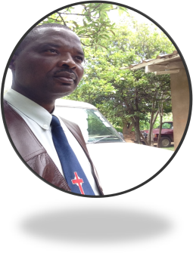

**Dr. D.T Banda** is a lecturer in New Testament, introduction, Introduction to New Testament Greek, and Worship at Justo Mwale University. D.T has interests in hermeneutics, governance, leadership and church polity. He holds a Phd in New Testament interpretation from the University of the Free State, Bln-RSA, and a Master of Arts in Political Science and Public Administration from Sam Houston State University- Texas, USA. He is a former Principal of JMU.

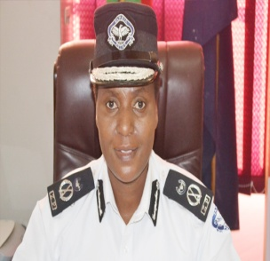**Mrs Joyce Kapampa Kasosa** is a Commissioner of Police in the Zambia Police responsible for the Copperbelt Province. She holds a Master of Science Degree from University of Leicester in UK and a Bachelor of Arts Degree from University of Zambia. She has worked with the United Nations (UN) at field echelon in Liberia (2004-2006) and at the UN Headquarters in New York (2008-2012) under the Department of Peacekeeping, Police Division. Joyce was one of the founder members as well as being the first founding chairperson of the Southern African Region Police Chiefs Cooperation (SARPCCO) Women’s Net Work Sub Committee. At home in 2007, she conducted an internal review and mapping to assess how the Zambia Police as a government institution was implementing the Zambia National Gender Policy (ZNGP) of March 2000 which recognised the need for equal and full participation of women and men at all levels of national development. She also spearheaded the formation of the Zambia Police Women’s Network which among its other objectives is to advance the empowerment of women police officers through training so that they qualify for leadership roles

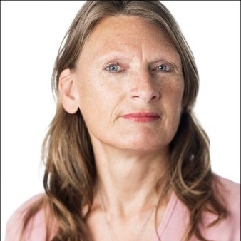**Dr. Thera Rasing** (Ph.D.) is an anthropologist specialised in gender studies and religion. She has conducted extensive research in Zambia for twenty five years, predominantly on female initiation rites, sexuality, gender, HIV/AIDS and traditional and Christian religion. She has worked as senior lecturer at several universities in The Netherlands, Malawi and Zambia. She was the Head of the Gender Studies Department at UNZA. She is currently affiliated as senior lecturer to the University of Africa and as researcher to CIDRZ. Her main publications are: *Passing on the Rites of Passage: Girls’ initiation rites in the context of an urban Roman Catholic community on the Zambian Copperbelt* (1995) and *The Bush Burnt, the Stones Remain: Female initiation rites in urban Zambia* (2001), and she was co-editor of the book *Religion and the Challenges of Aids treatment in Africa: Saving Souls, Prolonging Lives* (2014).



**Mrs Nelly Mwale** is Lecturer in the Department of Religious Studies at the University of Zambia. Her research interests are in Religion and Media, African Traditional Religion and Christianity in Zambia.

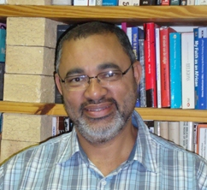

**Dr John Klaasen** is a lecturer in the Department of Religion and Theology at the University of Western Cape in South Africa. He research expertise is in the broad field of ethics and the interplay between theology and development. His current registered research project at the UWC is on “Theology and Development: The role of personhood in development.” His publications include, The interplay between theology and development: How theology can be related to development in post-modern society, Towards an approach to development as mission: the category of personhood as addressed by Armartya Sen and The ecumenical movement and Development among others.

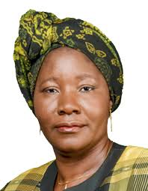

**Ms Edith Nawakwi** is Zambia’s first elected woman president of a political party - the Forum for Democratic Development ((FDD) as well as the first woman Minister of Finance in the Zambian government. She holds a degree in economics and business management and a post-graduate diploma in the economics of energy and development from the University of London Imperial College. She has held different ministerial portfolios in the government between 1992-2001.

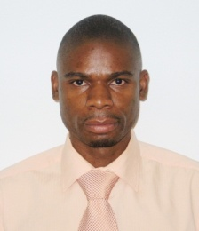**Mr Simson Mwale** is Head of Department for Development Studies at Zambia Catholic University. He is a PhD Student in Population Studies at the University of Zambia. He holds Master of Arts in Peace and Conflict Studies (CBU), Master of Population Studies (University of KwaZulu-Natal), Master of Communication for Development and Postgraduate Diploma in Human Rights Law (UNZA), Bachelor of Sacred Theology (Pontifical Urbaniana University) and Diploma in Philosophy (St. Augustine’s Seminary). He is author of “The Determinants of Sexual Behaviour Among Young People: Evidence from the Zambia Sexual Behaviour Survey” (2014), “The Basic Needs Basket Training Manual: A Practical Guide to Designing and Conducting an Evidence-Based Lobby and Advocacy Programme on Basic Needs” (2011), and “Monitoring Economic, Social and Cultural Rights in Zambia: An Introductory Handbook for Churches and NGOs” (2010).

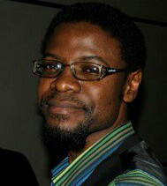

**Mr Joseph Chita** is lecturer in the Department of Religious Studies at the University of Zambia. Research Interests: Religious & Educational Discourse in public space.

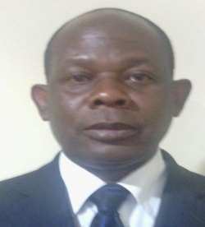

**Mr Clement Kasenge** is a retired secondary school head teacher and presently a lecturer in the school of Education at the United Church of Zambia University College, Kitwe, Zambia. He holds a Bachelor of Education Degree in Guidance and Counseling and a Master of Education in Literacy and Development. He is currently pursuing a doctoral degree in Education Management and Administration with the University of Zambia. He is one of the implementors of Gender and HIV/AIDS Work Place Policy in the Ministry of Education, Zambia. His publications include “Practical Guide to the Teaching of Civic Education in Zambia.”