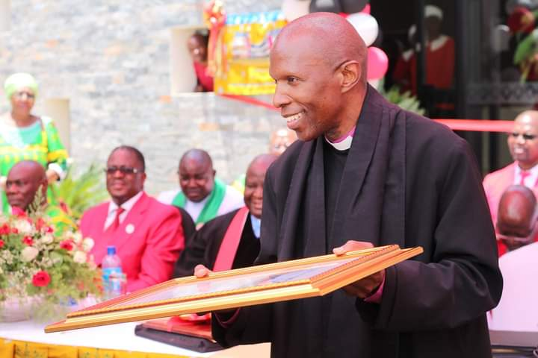

THE EASTER PASTORAL MESSAGE FROM THE UNITED CHURCH OF ZAMBIA SYNOD BISHOP, REV.SYDNEY SICHILIMA DELIVERED ON MAUNDY THURSDAY,14TH APRIL, 2022 AT THE UNITED CHURCH OF ZAMBIA SYNOD HEADUARTERS IN LUSAKA

‘HOPE OF EASTER’- “JOHN 20:1-19

Brothers and Sisters, I bring Lenten greetings from the United Church of Zambia Synod Headquarters to you all. Peace and Easter blessings be upon you!

I take this privilege and opportunity to speak to the Church during this important period on the Christian Calendar with gladness. I join you all and the global Christian family in celebrating the Resurrection of our Lord Jesus Christ. Easter reminds us of the reason the church exists. The church, being the family of God’s family exists to call others to Christian discipleship for fulfilment of the God-given mission. It is also an opportunity for Christians to recognise and respect their place in God’s mission, in the light of His victory over death, that brought enduring hope to humanity.

This year, we commemorate Easter period as The United Church of Zambia under the theme 'All One in Christ' (John 17:21) with the sub theme ‘Hope of Easter’, from John 20:1-18 and 1 Corinthians 15:12-20.

The theme of this Easter comes to us on the backdrop of our different encounters which in some respects are similar to what the early disciples experienced. The message of the resurrection of Jesus first broke forth to the disciples whilst they were in hiding, incumbered with sorrow, frustration and fear. They did not know what had happened to Jesus and at a time when they thought it was over for them, suddenly they received the good news that Christ had risen.

The Gospel according to St. John which we selected for this year’s Easter Sunday (John 20:1-19) presents us with an account that lies at the heart of the Message of the Church. In it we see that Jesus, who was crucified, has been raised from the dead. Mary, and other disciples witnessed the empty tomb, the outward and visible sign that Jesus has conquered death. They in turn went to tell others about the experience.
The other Evangelists noted that several women came to the tomb. We read from the account in Matthew’s Gospel that the women who went to the tomb were burdened with disappointment and grief, having witnessed the sacrificial death of Jesus. They were overwhelmed with fear and in that precise moment, they encountered Jesus who said to them, “Do not be afraid; go and tell my brothers to go to Galilee; there they will see me." (Mat 28:10, NRSV).

All Gospel accounts of this moment vary on some points, but what is consistent is that the risen Christ appears to them in the midst of their depressing condition, as a result, their condition is transformed from despair, fear and grief to that of hope and greater rejoicing.

Like the early disciples who first witnessed the resurrection of Jesus Christ, we celebrate this Easter amidst many challenges. The past two years have been difficult for the Church and the community as a whole. From the time the Covid-19 pandemic broke out, life has been characterized with grief, pain suffering and uncertainty. We witnessed the lives of our beloved ones depart to be with the Lord. In some cases, we could not gather in crowds to pay our last respects to them and share our ministry of physical presence with the bereaved families. we celebrated our Sunday services and sacraments under restrictions. At some point, the doors of our churches were closed from public gatherings while countries went on economic lockdowns. We celebrate this Easter at a time when the world has not recovered from the effect of the Covid-19, coupled with other political, social, economic and even religious challenges. This Easter season, we continue to wake up to sad news of the loss of our beloved ones and of those battling for their lives in homes and hospitals; sad news of high unemployment statistics; sad news of increased commodity prices; sad news of workers being laid off, sad news of disappointments; sad reality of rivalry and conflicts in families, places of business and work; sad news of suicide and gender based violence; among other vices that have gripped our nation and beyond.

Amidst such challenges, one would ask if this is the appropriate time to proclaim the Good News that Jesus Christ is risen and what implications such message can have on our community.

From the Gospel, it is in such and many situations that the risen Lord meets us and says: “Do not be afraid, go and tell my brothers and sisters that; I have seen the Lord!” it is midst such dark moments that Jesus’ response to the grief-stricken women and other disciples resounds victory and hope for us today, calling us to be signs of hope and be part of the renewal of our communities.
Furthermore, through the Gospel, Christians should be reminded that although the past and the present may be characterised with a long night full of struggle, setbacks, grief, frustrations and uncertainty, there is a dawning of a new day coming, announcing the defeat of the night. At an unexpected time and space such as this, our Saviour meets and is assuring us that the enemy of life, death, has been defeated, Christ reigns. Therefore, every Christian should be a signal of the reign of God in the communities they live and work.

Secondly, we see those two different ways of seeing are depicted in verses 5-8. Both John and Peter viewed the facts-the tomb was empty, with the burial cloths lying there, But the text implies that John saw at a deeper level; he believed.

Brothers and Sisters in The Lord, does this not exemplify different levels of faith and convictions prevalent in our church and communities today? Today, the tomb still stands empty, and people still can ‘see’ the evidence. But not everyone believes that Jesus has, in fact, overcome death and provided the only way to eternal life. There are still those who have heard the gospel but are still in deep shock because of the issues surrounding them. In all fronts of life, people will not be at the same level of understanding and the Christians are called upon to be signs of hope and help our brothers and sisters who can see the wonders of God but cannot believe instantly.

Those who can believe instantly should not malign the slow to belief just like those who run faster should not think they have seen it all. There is a way in which we can help one another to see beyond the present and past experiences.

Thirdly, through the Gospel, Christians are being called upon to demonstrate courage and love amid difficulty moments. This is exemplified in the courage demonstrated by Mary Madeleine and later that of the two disciples. Despite the pain of loss and fear of being killed that gripped, they chose to rise up to witness to the message of the resurrection of Jesus. They refused to remain there lying down in defeat. They put themselves onto the road, leading them out there to see and discern ‘signs ‘which enable them to perceive differently the absence of the body of Jesus. Let us resist the temptation of sitting on the debris and use the current challenges as an excuse for not demonstrating faith in the Lord. Let us not sit back on the rubbles of our social and economic life, as though life has come to an end. Christians must rise up and be part of the quest for revival of our communities engulfed into grieve and loss of hope. The Easter story is a story of victory and of life beyond the past and the present. It is a reminder that the past, present and the future are in the hands of God and that God alone has the final say on the destiny of human life.

Fourthly, the Gospel narratives are also consistent that women were among the first witness of the resurrection. That God chose the women to be the first to announce the message of the resurrection should signal to us the Gospel fact that God is God of all fresh. His mission is to all God’s People, including those whom society may have written off. With God on our side, men and women, the young and the old, regardless their social, political and economic status, can do than what society has ascribed them. Christians should be the embodiment of true hope and resist all manner of segregation based on one’s social status.

Finally, we read from the Gospels That when the Lord appeared to His disciples after His resurrection, He greeted them, saying, “Peace be to you.” At this point they were so scared of being killed by the Jews. The one who died and rose again appeared in their midst to assure them. So it is in our lives, the Lord Jesus stands in our midst in our fearful, defeated and frustrated state and says: “Peace I leave with you; my peace I give to you. I do not give to you as the world gives. Do not let your hearts be troubled, and do not let them be afraid. This peace does not mean the absence of trouble and conflict. It is the assurance of God’s wholeness among his people even amidst difficulties. I encourage the church to be an embodiment of peace amidst trouble and be a beacon of hope to the world.

Amen.

REV. BISHOP SYDNEY SICHILIMA
SYNOD BISHOP

14TH APRIL, 2022

